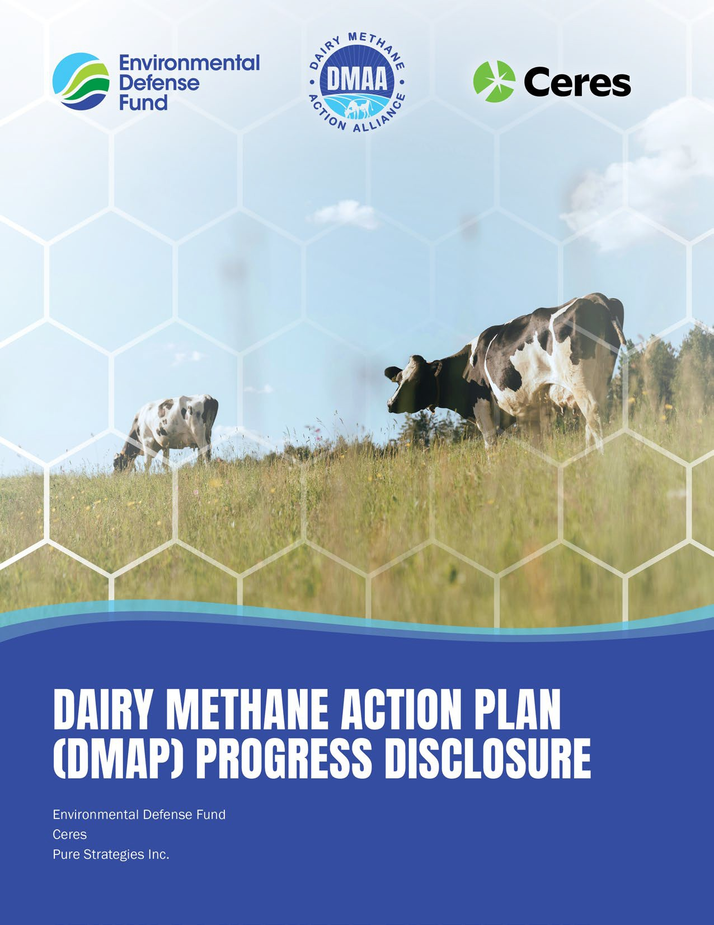

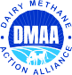

DAIRY METHANE ACTION PLAN (DMAP)
PROGRESS DISCLOSURE
Annual progress disclosure
DAIRY METHANE ACTION PLAN ( DMAP) PROGRESS DISCLOSURE
2
Company’s current Dairy Methane Action Plan (DMAP)

Link to publicly available DMAP:

Dairy methane emissions disclosure update

Total GHG emissions (Mt CO₂e/year)
Global warming potential (GWP) source used (e.g., IPCC Sixth Assessment Report – AR6 –100 year):

Baseline reporting year
[MM/YY-MM/YY]

Previous reporting year
[MM/YY-MM/YY]

Current reporting year
[MM/YY-MM/YY]
% Change from previous reporting year

% Change from baseline

Units

Mt CO₂e

Mt CO₂e

Mt CO₂e

%

%

Scope 1

Scope 2
Location-based or Market-based

Scope 3

Total (Scope 1-3)

DAIRY METHANE ACTION PLAN ( DMAP) PROGRESS DISCLOSURE
3

Agricultural dairy methane as % of total GHG emissions

Baseline reporting year
[MM/YY-MM/YY]

Previous reporting year
[MM/YY-MM/YY]

Current reporting year
[MM/YY-MM/YY]

Units
%
%
%
Scope 1

Scope 1, enteric

Scope 1, manure management

Scope 1, feed

Scope 3

Scope 3, enteric

Scope 3, manure management

Scope 3, feed

Total (Scope 1-3)

Agricultural methane emissions from dairy supply chain
Global warming potential (GWP) source used (e.g., IPCC Sixth Assessment Report – AR6 –100 year):

Baseline reporting year
[MM/YY-MM/YY]

Previous reporting year
[MM/YY-MM/YY]

Current reporting year
[MM/YY-MM/YY]

Current reporting year % of dairy methane
emissions

% Change from previous reporting year

% Change from baseline

Units
Mt CH₄
Mt CO₂e
Mt CH₄
Mt CO₂e
Mt CH₄
Mt CO₂e
%
%
%
Scope 1

Scope 1, enteric

Scope 1, manure management

Scope 1, feed

Scope 3

Scope 3, enteric

Scope 3, manure management

Scope 3, feed

Total (Scope 1+3)

DAIRY METHANE ACTION PLAN ( DMAP) PROGRESS DISCLOSURE
4
Qualitative explanation of changes in dairy methane emissions and progress towards goals from previous year

Explanation of any business shifts or external factors that may have resulted in changes in emissions unrelated to the company’s methane abatement strategies
(e.g., mergers and acquisitions, divestments, unrelated changes to dairy procurement and sales)

Update on status of implementing strategies and action items articulated in the DMAP
(e.g., new strategies or technologies added to the DMAP, strategies or technologies that were not successful or practical to apply; changes to key details such as expected timeline and/or plans for scaling interventions, implementation regions, KPIs, investments and capital expenditure alignment)
FARMER AND SUPPLIER ENGAGEMENT
Update on current action items

New action items

INNOVATION STRATEGY
Update on current action items

New action items

PUBLIC POLICY ADVOCACY STRATEGY
Update on current action items

New action items

