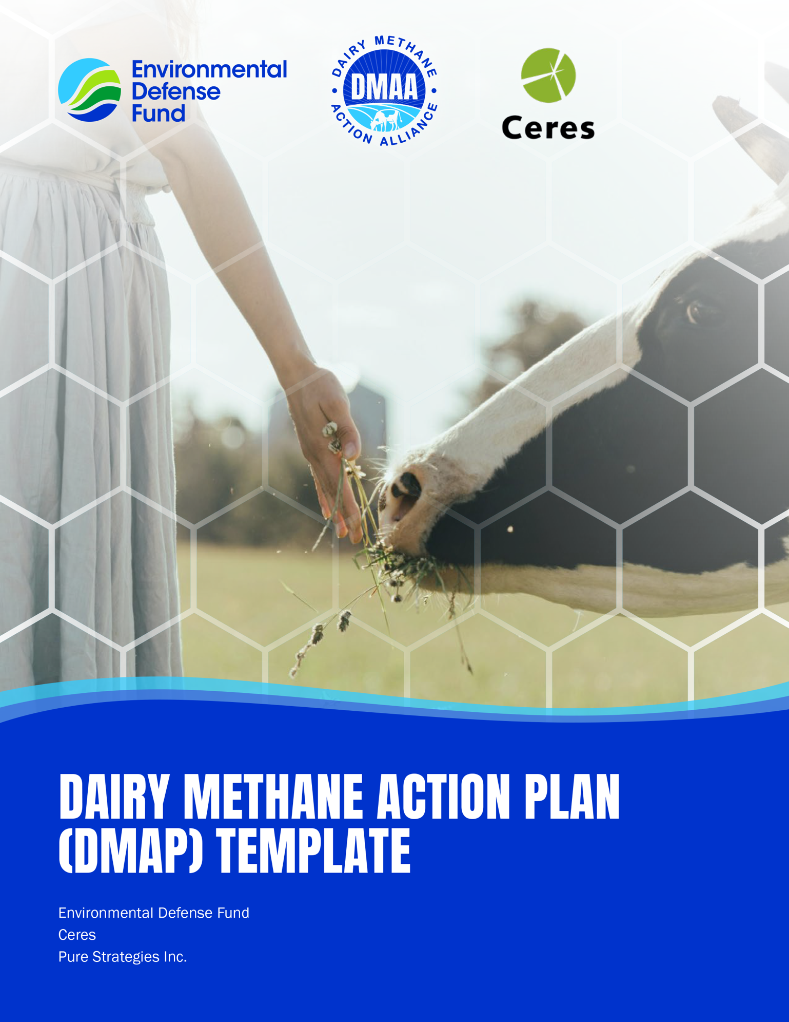

DAIRY METHANE ACTION PLAN (DMAP) TEMPLATE
Appendix 1: Dairy methane action plan (DMAP) template
Companies can use the template below to communicate their dairy methane action plan.

Part 1: Key disclosures
1

Annual methane emissions disclosure for the past three years
Methane emissions from dairy supply chain (Mt CH₄/year)
 | Baseline [year] | 2021 | 2022 | 2023 | Current [year] | % Change from previous year | % Change from baseline
Total emissions
Scope 1 emissions
Scope 2 emissions
Scope 3 emissions

Total GHG emissions (Mt CO2e/year)

 | Baseline [year] | 2021 | 2022 | 2023 | Current [year] | % Change from previous year | % Change from baseline
Total emissions
Scope 1 emissions
Scope 2 emissions
Scope 3 emissions

Dairy methane as % of total emissions
 | Baseline [year] | 2021 | 2022 | 2023 | Current  [year] | % Change from previous year | % Change from baseline
Scope 1 emissions
Scope 2 emissions
Scope 3 emissions

Emissions reduction targets
Company’s total GHG emissions reduction target:
- Target: [e.g., 30% reduction of 2020 emissions by 2030]
- Year target was set:
Company’s methane emissions reduction target:
- Target: [e.g., 30% reduction of 2020 emissions by 2030]
- Year target was set:

Qualitative explanation of key sources of dairy methane in company’s operations and supply chain

Part 2: Strategies to reduce dairy methane emissions
2

 FARMER AND SUPPLIER ENGAGEMENT STRATEGY
Dairy methane sources addressed
Context for strategy implementation
Key business changes from strategy implementation
How this strategy will address material climate-related physical and transition risks to the company
Scope, scale, and coverage across business
Business units involved

Industry, government, trade, and/or NGO groups engaged
Current status of strategy
Action items and key details
For each action item, complete the information below.
Concrete actions to advance strategy
Regions where interventions will be implemented
Expected start and completion dates
Key performance indicators (KPIs) to indicate success or failure
Estimated emissions reductions for individual interventions

Investments and capital expenditure alignment

 INNOVATION STRATEGY
Dairy methane sources addressed
Context for strategy implementation
Key business changes from strategy implementation
How this strategy will address material climate-related physical and transition risks to the company
Scope, scale, and coverage across business
Business units involved
Industry, government, trade, and/or NGO groups engaged

Current status of strategy
Action items and key details
For each action item, complete the information below.
Concrete actions to advance strategy
Regions where interventions will be implemented
Key performance indicators (KPIs) to indicate success or failure
Investments and capital expenditure alignment

 PUBLIC POLICY ADVOCACY STRATEGY
Dairy methane sources addressed

Context for strategy implementation
How this strategy will address material climate-related physical and transition risks to the company
Industry, government, trade, and/or NGO groups engaged
Current status of strategy
Action items and key details
For each action item, complete the information below.
Concrete actions to advance strategy
Regions where interventions will be implemented
Specific policies supported
Participation in regulatory processes

Part 3: Additional considerations for DMAPs
3

Barriers and systemic challenges related to DMAP implementation
Barriers that prevent farmers and suppliers from adopting near-term methane mitigation solutions and how the company will address these barriers
Systemic challenges that limit scope of methane mitigation and intent to monitor
Just transition considerations
Actions taken or that will be taken to ensure a just transition and to address risks of transition to suppliers, including farmers and farmworkers
Activities to support the company’s existing workforce, vulnerable customers, and at-risk communities during transition
(e.g., Sharing the cost of transition to low methane practices, considering food affordability)
Actions to consult and implement feedback from the company’s workforce, suppliers, impacted communities, and NGOs

Measurement and accountability mechanisms in place
Synergies of the DMAP with other sustainability goals and programs
Disclosure of non-dairy methane emissions and plans to address them
Long-term planning for dairy methane reduction (beyond 5-10 years)

Part 4: Annual DMAP progress disclosure
4

Scope 1 and 3 dairy methane progress
Methane emissions from dairy supply chain (Mt CH₄/year)
 | Baseline [year] | Current [year] | % Change from previous year | % Change from baseline
Scope 1 emissions
Scope 3 emissions

Qualitative explanation of changes in dairy methane emissions and progress towards goals from previous year
Update on status of implementing strategies articulated in the DMAP
Explanation of any changes to the business or external factors that may have resulted in changes in emissions unrelated to the company’s methane abatement strategies
(e.g., mergers and acquisitions, divestments, unrelated changes to dairy procurement and sales)
New strategies or technologies that can be added to the DMAP to improve performance
(e.g. increase emission reduction, meet target reduction faster, reduce cost, ease of use)
Strategies or technologies that were not successful or practical to apply and whether or not they will be removed from the DMAP

